AHMAD  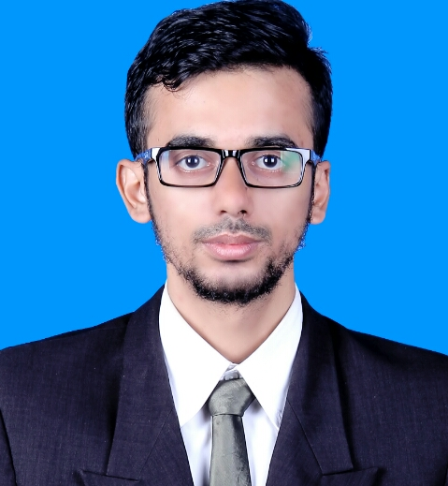  Smart RNO | (+62) 8983060304(Indonesia)  (+60) 1114281791(Malaysia)  Matt.syahab@gmail.com

birth 29th of November, 1990. Bachelor degree graduated from University of Sriwijaya, Informatics Engineering Majors, Have Telecommunication experiences at least 3 years , Network Optimization, Problem Solved, and Analysis person.
.
Skills Optimization
Optimization for new site ,swap site and Cluster (Physical Tuning and Parameter Tuning) (Huawei - Telkomsel - Celcom)
Parameter and Neighbor Relation
Prepare and Execute Parameter and Relation neighbor for new site, swap site , and Cluster be based from Customer Parameter and Relation Strategy. (Huawei – Nokia - Celcom)
Reviewer
Reporting and Reviews to Customers based on Project needs for Acceptance. (Huawei - Telkomsel)

CDD Planning
Updated and Change CDD from Customer (Huawei - Nokia - Celcom)

KPI Monitoring
Monitoring new site , swap site and Cluster due to KPI Degrading issue, find the contributor and also solve the issue. (Huawei – Telkomsel - Celcom)
Generate Dump or CFGMML
Prepare and Generate Dump (2G,3G and 4G) as requested from Customer , Vendor or Team. (Huawei – Nokia - Celcom)
Reporting and Analysis
Prepare report new site, swap site and Cluster based on Customer Template Report from Drive Test logfile, analyze the result, Drive Test plot, KPI statistic before Submission the report. (Huawei – HCPT – Telkomsel – SmartFren)
Macro
Using Excel macro for processing data ongoing activities. (All Project)
Mapinfo and Google Earth
Mapping new site, swap site and Cluster to mapinfo purpose to facilitate and assist analyze missing Relation, Contour issue, Overshot, Overtilt, Head to Head Direction, low traffic site, sharing site and another plan for optimization. (All Project)
U2000, PRS, LMT and another Huawei tools
Use U2000, PRS, LMT and another Huawei tools purpose to config Huawei Site Parameter, Neighboring, Query KPI, to find the Contributor due to Degrading KPI Issue, CFGMML Huawei data. (Huawei – Telkomsel - Celcom)
NetAct
Query Nokia KPI based on Customer request for Benchmarking Before and After Swap from Nokia to Huawei. (Huawei -Nokia - Celcom)
Simon Analyzer
Query KPI based on Customer request for Benchmarking Before and After Swap from Nokia to Huawei. (Huawei -Nokia - Celcom)
Microsoft Office
Skillful Operate office tools. (All Project)
Programming
Java gui builder programming.
DriveTest
Prepare and make Route for Drive Test new site, swap site and Cluster. (Huawei – Samsung - HCPT – Telkomsel- SmartFren)
Experience Elabram System SDN BHD 2016-Now(6 Month)
Huawei SmartRNO (Celcom)
As SmartRNO have responsibility to Prepare, Generate, and Execute Parameter and Relation Script before and after swap also have Responsibility to Concheck Parameter and Neighbor before and after Swap. Generate and Analyze KPI before and after swap.

PT Global One Solution 2015-2016(7 Month)
Jr RNO (Telkomsel) RF Optimization (HCPT)
Reporting, Analyze Drive Test logfile for Balikpapan Cluster. Physical Tuning Overshot, Overtilt, LTC and Head to Head site for submission Weekly. (2 Month HCPT)
Reporting, Analyze, Create Relation, Parameter Tuning, Reviewer for new Site Palembang. (5 Month Telkomsel)

PT UCE 2013-2014(1 Year)
Drive Test Engineer and Analyzer (HCPT – Telkomsel)
Drive Test new Site and Swap site (Telkomsel), Drive Test Cluster (HCPT).

PT Qutec Global 2013-2013(6 Month)
RF Engineer (SmartFren)
Drive Test, Reporting and Analyze for Evdo and 1x System.
Education Sriwijaya University 2008-2015
S.Kom, Informatics Engineering

